Key points for students
The Python editor
The Python editor will help you learn how to code in Python. It can run in two different modes, blocks or text.
The first time you open the application, the platform will default to the text mode. 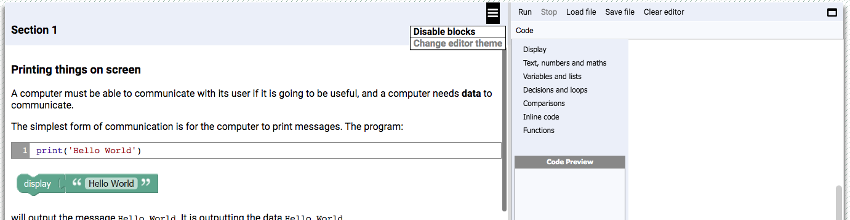

To enable the blocks, click on this menu icon and choose 'Enable blocks'.
To go back to text you can select ‘Disable blocks’ from the same menu.
The left-hand side of the screen contains the learning material that you will work through.
As you work through the material you will come across Quick Quiz questions that test your understanding of what has just been covered.
These questions provide immediate feedback.
You will also come across bronze, silver and gold medal challenges. These are more formal tests.
For these challenges you need to: write some code and
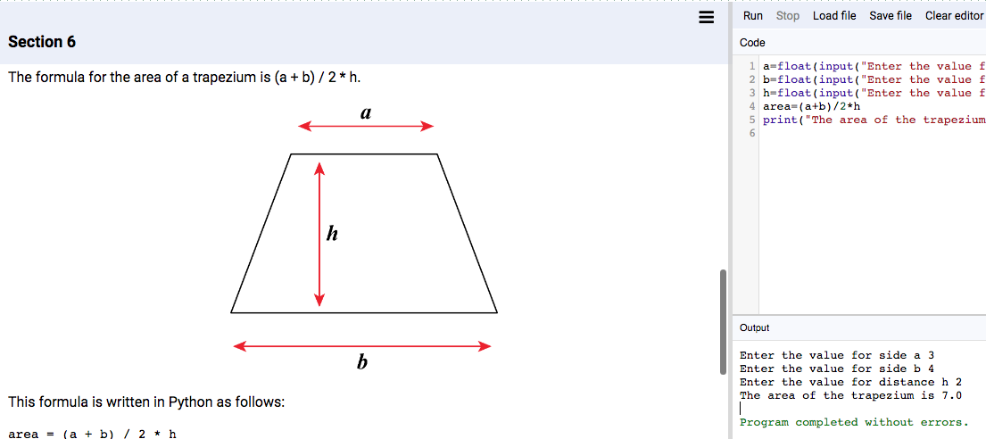
test that it works as expected.
Then submit your code for auto-marking.
If you have completed the task successfully you will receive a medal.
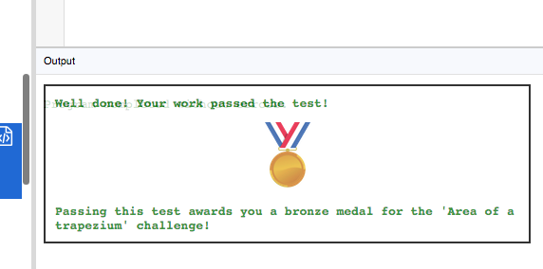
If you make a mistake in the code you will receive some feedback to help you identify and correct the error:
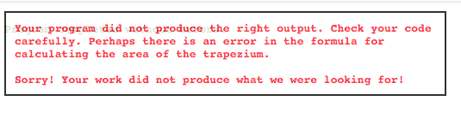
You need to make sure that your code runs without any errors.
You can run code as many times as you like but you should aim to only ‘click to test’ once the code runs without errors.
The menu options for the coding window are as follows:
- Run: executes the code currently in the window.
- Stop: terminates the code that is running. This is useful if a program is waiting for an input or is stuck in a loop.
- Save file: the code in the editor can be saved onto a local drive.
- Load file: a file can be loaded into the coding window.
- Clear editor: clears all the code in the coding window.
In blocks mode, Google Blockly is used to give a visual representation of Python.

Clicking on the categories on the left of the coding window displays the available blocks for each category.
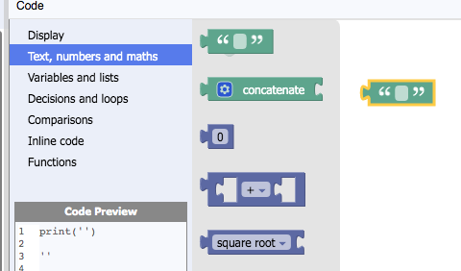
Clicking on a block selects it and inserts it into the coding window.
Once in the window, blocks can be moved and attached together.
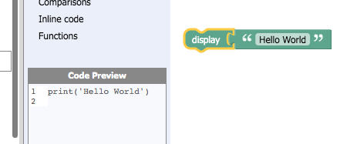
The equivalent Python code is displayed in the code preview window.
The most common errors you are likely to make are:
Syntax errors: These are mistakes in the structure of the code meaning it will not run.
Look for these common error messages:
- EOL while scanning string literal
The most likely causes are missing opening and closing quotation marks in a print
statement. Make sure that the same type of quotation marks ' and ' or " and " are used throughout.
- Invalid syntax
The most likely cause is a missing bracket. Make sure there are the same number of opening and closing brackets in each line of code.
- TypeError
The most likely cause is an incorrect variable type. Make sure you use int or float or str to cast the variable type.
Logic errors: These are mistakes in the logic of the program. It may run but give incorrect or unexpected results.
Try these strategies to find the problem:
- Nothing is output to the screen
Make sure you have used suitable print lines and that these refer to the correct variables. Follow the program through line by line to make sure everything is in the correct sequence.
- The value(s) output are not correct
Make sure you have used the correct operators and formulae or variables, text and formatting. Follow the program through line by line to make sure everything is in the correct sequence.

